INSTRUCTIONS FOR PREPARING AN EXTENDED ABSTRACT FOR
THE 29th INTERNATIONAL WORKSHOP ON ELECTROMAGNETIC NONDESTRUCTIVE EVALUATION (ENDE26)
PARIS-SACLAY, FRANCE, JUNE 3-5, 2026
First AUTHOR¹, Second CO-AUTHOR^{1,2} and Third CO-AUTHOR²
¹Affiliation 1
²Affiliation 2
Abstract
This template contains specific instructions on how to prepare abstracts for the 29th International Workshop on Electromagnetic Nondestructive Evaluation that will be held in Paris-Saclay, France, on June 3-5, 2026. The abstract needs to be prepared in A4 paper size with the margins set at 2.5 cm. The maximum number of content pages is limited to two. The authors are strongly suggested to use this template.
The title of the abstract should be typed using 14 pt “Times New Roman” UPPERCASE bold font. The names of the authors, their affiliation and the main text of the document should be typed using 11, 10, and 11 pt “Times New Roman” font, respectively. There should be a blank line between the blocks.
In order to submit your abstract, please follow the instructions on the conference website: ende2026.sciencesconf.org. The deadline for submission of the abstract is December 15, 2025. Accepted abstracts will be notified to the corresponding author of the abstract by email by February 10, 2026. For any questions about abstract preparation or anything related to the conference, please do not hesitate to email to the Conference Secretariat.
Keywords: ENDE, extended abstract preparation, submission instructions
Main body
Text blocks should be left justified; figures, captions and equations should be center justified. Authors can include equations, figures and/or tables if they are referred to within the text, e.g. Figure 1. Figure and table captions should be typed using 10 pt “Times New Roman” font. Table contents should share the same size with their caption.
$∇×E=-\frac{dB}{dt}$ (1)
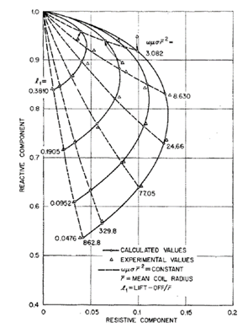
Figure 1. A figure and caption center justified.
Column1 | Column2 | Column3
–10.2 | 10.2 | 10.2
5.36 | 6.32 | 6.32
–5.7 | 5.7 | 0.326
Table 1. A table and caption center justified.
As the abstracts will be distributed to attendees in electric form, the figures can be prepared in color. References and acknowledgments must be at the end of the abstract, and do not count against the two-page limit.
Acknowledgements
Any acknowledgements to third-party contributions, funding, etc., should be given here.
References
- J. D. Jackson, Classical electrodynamics, 3rd Edition, John Willey & Sons, Inc., New Jersey, 1998.
- Dodd C. V. Deeds and W. E. Analytical solutions to eddy-current probe-coil problems, J Appl Phys 1968; 39(6): 2829-2838.
- Auld, B.A. John Moulder and the Evolution of Model-Based Quantitative Eddy Current NDE. In: Thompson, D.O., Chimenti, D.E. (eds). Review of Progress in Quantitative Nondestructive Evaluation (QNDE 1999), vol. 18 A. Springer US; 1999, pp. 441-448.

Corresponding author. E-mail address:

